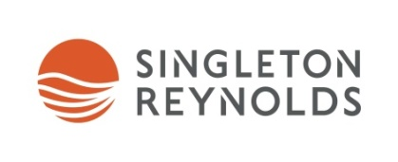
Singleton Reynolds 1L Litigation Fellowship
Singleton Reynolds Urquhart Vogel LLP will award one 1L Allard Law Student with a 14-week Fellowship for the summer of 2019.
The $14,000 Fellowship will provide the selected student with the opportunity to work with our Director of Research & Knowledge Management for half of the summer on a legal research project. The intention of the project is to write an article or contribute to a textbook for publication.
The selected student will spend the other half of the summer gaining practical legal experience working on defined litigation projects with our lawyers. The projects will be focused on one or more of our litigation practice areas, including commercial litigation, construction and infrastructure law and insurance.
The Fellow will participate in our SR Institute Orientation Week alongside our summer and articling students. Orientation sessions include Legal Research & Writing, Litigation Precedents and Junioring 101. Additional legal training opportunities will be offered throughout the summer. The Fellow will be included in the teambuilding and social events planned for the students.
Applicants for the Singleton Reynolds Litigation Fellowship must currently be in their first year at Allard School of Law. The application deadline is January 28, 2019 and interviews will take place during the week of February 11-15, 2019. Please include a cover letter, resume, undergraduate transcript and your mid-term grades in your application package.
For more information about the Fellowship, please contact Kristy Foreman, Director of Student Recruitment and Professional Development at kforeman@singleton.com.
To find out more about the work we do at Singleton Reynolds, please visit our website at www.singleton.com.

