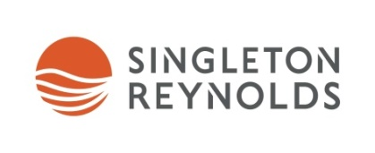
Singleton Reynolds 2020 1L Litigation Fellowship
As part of Singleton Reynolds' ongoing commitment to legal education, we will award one first-year law student with a 14-week Fellowship for the summer of 2020. Only 1L students attending UBC Allard Law and the University of Victoria are eligible to apply for the 2020 Fellowship.
The $17,500 Fellowship will provide the selected student with the opportunity to contribute to an academic project while also gaining experience working in a law firm setting. The student will work closely with our Director of Research & Knowledge Management and other lawyers on an innovative legal research project with the potential for publication.
The selected student will also gain practical legal experience and observational learning opportunities. They will work alongside our 2L summer students and articling students on litigation assignments throughout the summer. The student will gain exposure to many of our litigation practice areas, including Commercial Litigation, Construction and Infrastructure law, Entertainment Law, Workplace Law and Insurance.
The selected student will join the other students in our Singleton Reynolds Institute Orientation during the week of May 4, 2020. Orientation sessions will include Legal Research & Writing, Workload Management and Junioring 101, as well as substantive overviews of our practice areas. The selected student will be included in teambuilding and social events planned for the students throughout the summer.
We are looking for 1L students with a strong academic background, entrepreneurial spirit, interest in litigation and a collaborative work ethic. The application deadline is January 29, 2020 and interviews will take place during the week of February 10-14, 2020.
Application packages should contain a cover letter, resume, undergraduate transcript and mid-term law school grades in a single PDF file. Applications should be directed to Kristy Foreman, Director of Student Recruitment and Professional Development and emailed to recruitment@singleton.com. Students selected for an interview will be asked to provide a writing sample.
If you have any questions about the Fellowship, our student program or Singleton Reynolds in general, please contact Kristy Foreman at kforeman@singleton.com or visit our website at www.singleton.com.

