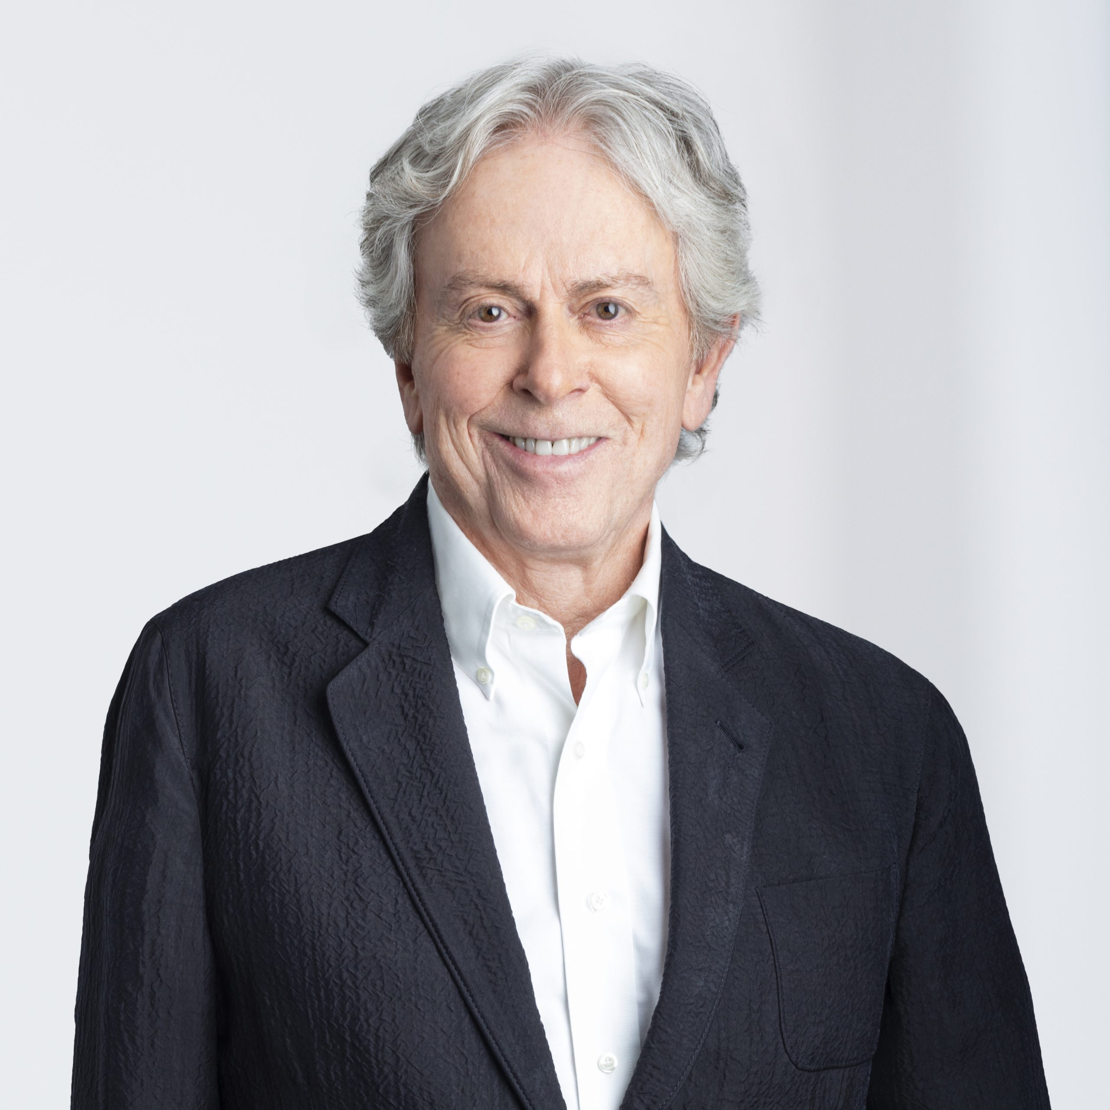

John R. Singleton
Counsel
Alternative Dispute Resolution, Construction and Infrastructure Law, Commercial and Business Litigation, Directors and Officers Liability, Insurance, Professional Liability, Domestic and International Arbitration
(604) 682-7474
jsingleton@singleton.com
https://www.linkedin.com/in/john-singleton-aaab2631/

Professional Background
John Singleton is a principal legal figure in the country’s construction industry, having played key roles in major developments across Western Canada. He founded the firm in Vancouver, in 1982, with a vision of creating a practice that would stand out for its expertise in construction and infrastructure law. Today, Singleton Urquhart Reynolds Vogel LLP serves clients across the country and is recognized internationally for its knowledge and insight.
John has acted as Counsel in precedent-setting cases involving insurance, construction, liability and environmental matters. He offers extensive experience in major infrastructure projects and public private partnerships, as well as complex commercial disputes.
John is an accomplished Mediator and Arbitrator. He earned the chartered arbitrator designation (C.Arb) from the ADR Institute of Canada, and over the past decade has served as fairness advisor on more than 85 infrastructure projects, ranging from the construction of hospitals and hydro energy enterprises, to the building of the RCMP headquarters in Surrey, B.C.
He has dedicated significant time to sharing his knowledge through academia and professional journals. He is an adjunct Professor of Law at the University of British Columbia and the Thompson Rivers University, and was a visiting lecturer at Stanford University’s law school.
John is consistently recognized as a leader in the construction legal field, regularly earning top rankings from Lexpert, Best Lawyers, Who’s Who Legal, Martindale-Hubbell and others. Benchmark Canada has designated him a “litigation star” and Chambers Canada recently labelled him a “top gun.”
Outside of the firm, John maintains a long-term relationship with Arts Umbrella, the not-for-profit arts education centre dedicated to inspiring children and young adults. Over the past 20 years he has served as a member of the organization’s board, as President and as Legal Advisor.

Education
- Called to the: Alberta Bar, 1970; Saskatchewan Bar, 1981; British Columbia Bar, 1982; Yukon Bar, 1984
- Master of Laws: University of London, London School of Economics and Political Science, 1971
- Bachelor of Laws, University of Alberta, 1969
- Bachelor of Arts, Economics, University of Alberta, 1966
- Member of the Law Societies of Alberta, Saskatchewan, British Columbia, and Yukon

Rankings + Recognition
- Recognized in the Hall of Fame as a top lawyer in Canadian construction by The Legal 500.
- Recognized as a leading lawyer in the Lexpert® Special Edition on Litigation.
- Ranked in the areas of Alternative Dispute Resolution, Construction Law, Corporate and Commercial Litigation, Insurance Law, Product Liability Law, Public Procurement Law, and Transportation Law by Best Lawyers Canada®.
- Recognized as a Leading Lawyer in the areas of Construction (most frequently recommended), Commercial Arbitration, Commercial Insurance, Product Liability, Infrastructure in the Canadian Legal Lexpert® Directory.
- Recognized in the Lexpert®/American Lawyer Guide to the Leading 500 Lawyers in Canada (Construction Law).
- Recognized as a Leading Lawyer for Infrastructure Law in the Canadian Lexpert® /Globe and Mail Special Edition.
- Recognized as a Leading Lawyer for Energy Law in the Canadian Legal Lexpert® Globe and Mail Special Edition.
- Recognized by Benchmark Canada Awards as “Hall of Fame Lawyer of the Year”.
- Recognized in Benchmark Canada — The Definitive Guide to Canada’s Leading Litigation Firms & Attorneys as a “Litigation Star”.
- Recognized in Who’s Who Legal as one of the top construction lawyers in Canada.
- Recognized in Who’s Who Legal as one of the top insurance lawyers in Canada.
- Martindale-Hubbell® AV® Preeminent™ 5 out of 5 peer review rated.
- Recognized in the Chambers Canada — Canada’s Leading Lawyers for Business (Construction) as a Band 1 practitioner in the area of construction law. Sources describe John as a “real top gun” and praise him as a “perceptive, experienced and knowledgeable” practitioner.

Memberships
- Member, Society of Construction Lawyers
- Fellow, Construction Lawyers Society of America
- Member, Diversity Law Institute
- Member, Trial Law Institute
- Fellow, Canadian College of Construction Lawyers
- Member, Federation of Defence and Corporate Counsel
- Member, Defence Research Institute
- Member, Arbitrators Institute of Canada
- Arbitrator, American Dispute Resolution Center
- Member, Association of Defense Trial Attorneys
- Member, panel of arbitrators of China International Economic and Trade Arbitration Commission and Hong Kong International Arbitration Centre
- Member, Kuala Lumpur and Singapore International Arbitration Centres

Experience
- Legal counsel on precedent-setting cases in the construction and insurance industries.
- Chartered arbitrator and mediator.
- Fairness advisor on dozens of infrastructure projects in the past decade.
- Active lecturer and speaker at courses on construction, insurance and environmental law.
- Visiting lecturer at Stanford Law School.
- Adjunct professor, University of British Columbia, faculty of law.
- Adjunct professor, Thompson River University, faculty of law.

Publications
- Co-author, “First Past the Post – What’s at Stake for the Industry in Surespan Structures Ltd. v. Lloyds Underwriters,” Canadian Underwriter, May, 2021
- Co-author, “Keeping a lid on it: Managing Your Communication to Effectively Preserve Privilege,” On-Site Magazine, March, 2021
- Co-author, “Yongfeng Holdings Inc. v. Zheng: The Need for Strict Compliance when Registering a Claim of Builder’s Lien,” December, 2019
- Co-author, “On Acts and Accidents,” Insurance People, November, 2018
- Co-author, “A New Construction Act – What Has Changed and How Will It Affect P3 Projects?,” Lexpert Special Edition on Infrastructure, September, 2018
- New Duty of Honest Performance of Contractual Obligations
- How To Operate When You Cooperate
- Keeping Out of Trouble in 2013
- The Law of Tenders: Fair Today, Gone Tomorrow
- When Is a Contract a Contract?
- Thinking of Contracting in the United States?
- Dealing Fairly with Subcontractor Bids
- Building Information Modelling (BIM): the Good and the Bad
- CLIENT ALERT- If It’s Brokered It Can’t Be Fixed
- Class Dismissed
- Public Private Partnerships: A Paradigm Shift
- Thinking of Retiring?
- No Insurance for Faulty Workmanship or Materials
- Insurer Required to Defend Civil Lawsuit Involving Criminal Acts
- New Client Identification and Verification Rules for BC Law Firms
- CLIENT ALERT – When is a Design “Faulty”?
- Computers Blackberrys and E-Discovery
- Resolving Foreign-Interest Business Disputes in the People’s Republic of China: II
- Resolving Foreign-Interest Business Disputes in the People’s Republic of China: I
- Thoughtless and Careless Neighbours
- Right to Negotiate with Bidders in the Procurement Process
- CLIENT ALERT – Right to Negotiate with Bidders in the Procurement Process

Presentations
- Panelist, “Managing Complex Coverage Claims,” Canadian Defence Lawyers, 16th Annual Insurance Coverage Symposium
- Speaker, Construction Projects: Risk Management for Modern Challenges, Pacific Business & Law Institute
- Coordinator of and frequent Speaker at courses on Construction, Insurance and Environmental Law
- Active lecturer and author of papers on Loss Control, Construction Law, Insurance Law, Environmental Law and other subjects for trade and legal publications
- Visiting Lecturer, Stanford University Law School, Palo Alto, California
- Adjunct Professor, University of British Columbia, Faculty of Law

Community + Volunteering
John has served as board member, president and legal advisor during the past two decades to the Arts Umbrella, a remarkable organization offering music, dance and visual and performing arts programs to over 20,000 children and young adults each year.

